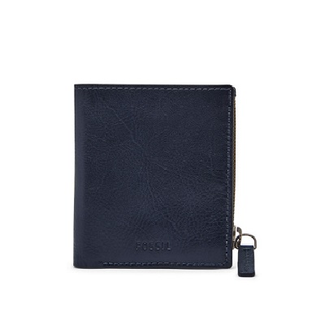

PHILIP COIN POCKET BIFOLD

PRODUCT DETAILS

**Silhouette: Coin Pocket Bifold**

**Exterior Material: Leather**

**Interior Details: 1 Bill Compartment and 6 Credit Card Slots**

**Measurements: 3.5"L x 0.75"W x 3.75"H**

**Warranty: 1 Year Limited**